**RRWM Assignment 2: Post-RRWM Report & Discussion**

**Poll:** Were you able to reproduce the work based only on the program (not the code)?  
• *Program doesn’t even make a table that looks like what I was sent.*

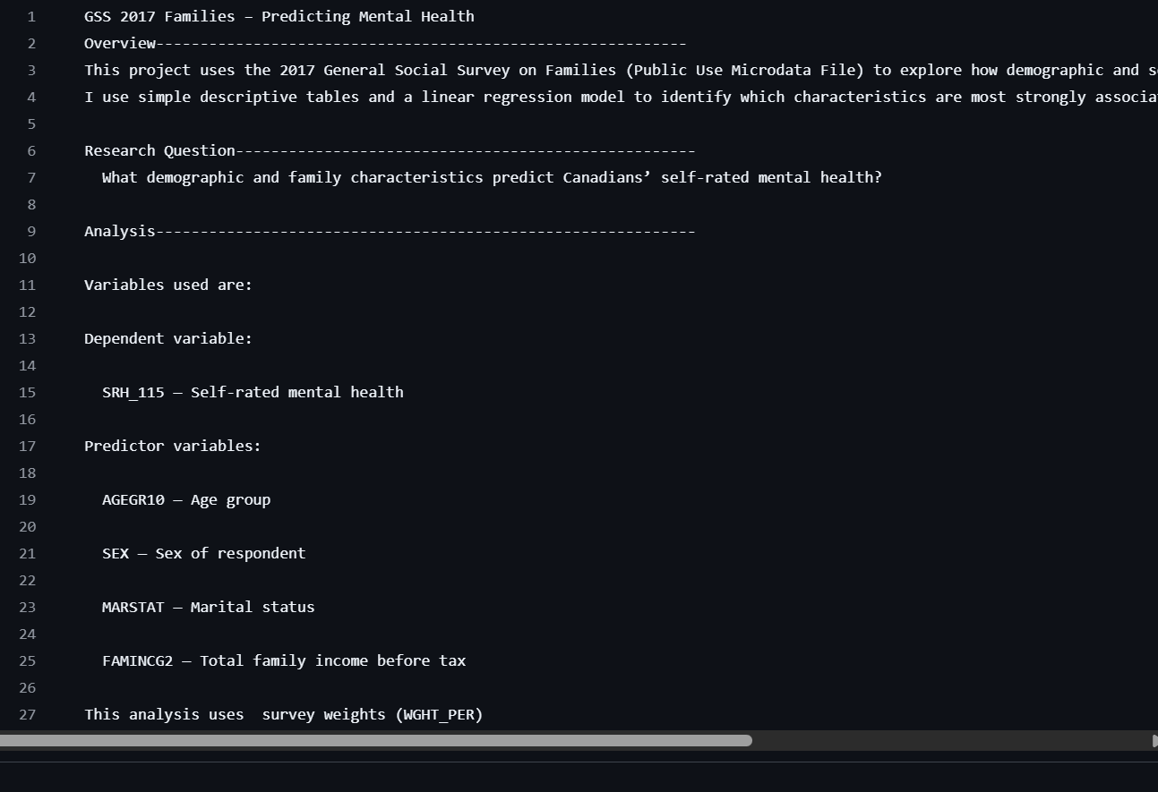The reason for this is as follows: my partner Fabio and I did not fully understand what the exercise was about. We had instead shared files via GitHub containing the **script**, rather than a **program (in text format)** describing the different steps to follow — namely, the selection of variables, their coding and cleaning, and the generation of descriptive and regression tables.  
Nevertheless, using the code and the image file, we were able to easily reproduce the tables and results of these analyses (see image files below).

**Where did things go off track? Was there one error that caused everything to go wrong?**

Since I based my work on the code file, here is what I noticed:

Even though I used setwd() to set my working directory and access the database, executing the command to load the dataset kept returning an error message, as shown above. It seemed that the R Markdown script forced me to work in a specific directory that was not the one I had defined. I had to open a new script and copy-paste each of the commands shown in the figure to solve the problem.

**What parts of the program left you uncertain about what to do?**

In my case, the variable coding was clear.

**Do you have any comments or reflections about the reproducibility exercise? For instance, has it changed your mind about the benefits (or costs) of open science?**

This exercise is very useful. In fact, I recently submitted an article to a journal that required me to make my results reproducible by sharing the data I used via GitHub.  
However, I think reproducibility should be limited to sharing the **code files or scripts** developed by participants. Moreover, I believe that the words *program* and *reproducibility*, when used together, refer to writing lines of code using a software program and sharing them with the scientific community.

**For those in fields where replication materials are not readily available, could an emphasis on reproducibility disadvantage researchers who use qualitative methods or restricted (e.g., administrative) data?**

I don’t think so. For researchers using qualitative methods, it is possible to share their “research protocol” with the scientific community, including the sampling procedure, the interview guides (individual and group), and the methods of analysis.  
As for restricted data, most scientific journals require authors to state that such data are only available upon request from the data-holding institution.  
Therefore, regardless of the field of research, there is always some framework that allows the reproducibility of results to be assessed — or at least approached.